S4.9
Intraperitoneal Metabolic Consequences of Supra-celiac Aortic Balloon Occlusion versus Superior Mesenteric Artery Occlusion - an Experimental Animal Study utilising Microdialysis
Tal M. Hörer M.D¹, Per Skoog M.D¹, Kristofer F. Nilsson¹, Lars Norgren M.D PhD², Kjell Jansson M.D PhD² and Thomas Larzon M.D PhD¹
¹Dept. Of Cardio-Thoracic and Vascular Surgery, ²Dept. of Surgery, Örebro University Hospital and Örebro University, Sweden

Objectives: To investigate by intrapertitoneal microdialysis (IPM) and Laser Doppler flowmetry the effect of supra-celiac balloon occlusion (ABO) and superior mesenteric artery (SMA) occlusion on abdominal visceral ischemia in an animal model.
Methods: Nine pigs were subjected to ABO and seven animals were subjected to SMA occlusion for one hour followed by three hours reperfusion. Seven animals served as controls. Hemodynamic data, arterial blood samples, urinary output and intestinal mucosal blood flow (IBF) were followed hourly. Intraperitoneal (i.p) glucose, glycerol, lactate and pyruvate concentrations and lactate-pyruvate (l/p) ratio were measured by microdialysis.
Results: Compared to base-line ABO reduced IBF by 76% (p<0.001 vs. control) and decreased urinary output by 92% at one hour reperfusion (p=0.003 vs. control) while SMA occlusion reduced IBF by 75% (p<0.001 vs. control) after one hour ischemia. I.p l/p ratio in the ABO group increased from 20 at baseline and peaked at 47 (p=0.022 vs. control) at one hour of reperfusion; Thereafter it decreased. I.p l/p ratio in the SMA group was 39 at the last hour and was higher than controls (p=0.029). I.p glycerol increased from 87 µM at baseline to 579 µM after three hours of reperfusion in the ABO group (p<0.001 vs. controls). I.p glycerol increased in the SMA group compared to controls (p=0.007).
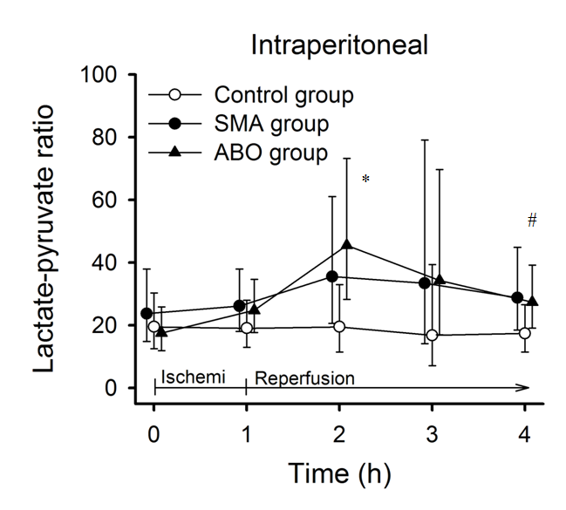
Conclusions: ABO substantially decreased IBF and urinary output by occluding urinary blood flow and collateral circulation and caused profound hemodynamic changes not seen by SMA occlusion. I.p l/p ratio increased temporarily but decreased during reperfusion phase. I.p glycerol increased during ischemia and reperfusion. These changes indicate a temporary shift to anaerobic metabolism and cell damage during aorta occlusion, detected by IPM.

