S4.8
Intraperitoneal Microdialysis and Intra Abdominal Pressure after Endovascular Repair of Ruptured Aortic Aneurysms

Tal M. Hörer M.D¹, Per Skoog M.D¹, Lars Norgren M.D PhD², Anders Magnuson BSc⁴, Lars Berggren M.D PhD ³, Kjell Jansson M.D PhD² and Thomas Larzon M.D PhD¹
¹Dept. Of Cardio-Thoracic and Vascular Surgery, ²Dept. of Surgery, ³Dept. of Anesthesia and Intensive Care ^{4,} Clinical Epidemiology and Biostatistics unit
Örebro University Hospital and Örebro University, Sweden

Objectives: To evaluate intraperitoneal (ip) microdialysis after endovascular aortic repair (EVAR) of ruptured abdominal aortic aneurysm (rAAA) in patients developing intraabdominal hypertension (IAH), requiring abdominal decompression.
Design: Prospective study
Methods: Sixteen patients with rAAA treated with an emergency EVAR were followed hourly for intraabdominal pressure (IAP), urine production and ip lactate, pyruvate, glycerol and glucose by microdialysis, analysed only at the end of the study. Abdominal decompression was performed on clinical criteria, decompressed (D) and non-decompressed (ND) patients were compared.
Results: The ip lactate/pyruvate (l/p) ratio was higher in the D group than in the
ND group during the first 5 postoperative hours, (mean 20 vs. 12), p=0.005 and at one hour prior to decompression compared to the fifth hour in the ND group (24 vs. 13), p=0.016. Glycerol levels were higher in the D group during the first postoperative hours (mean 274.6μM vs. 121.7μM), p=0.022. The intraabdominal pressure was significantly higher only at one hour prior to decompression in the D group compared to the ND group at the fifth hour (Mean 19 mmHg vs. 14 mmHg), p=0.015.
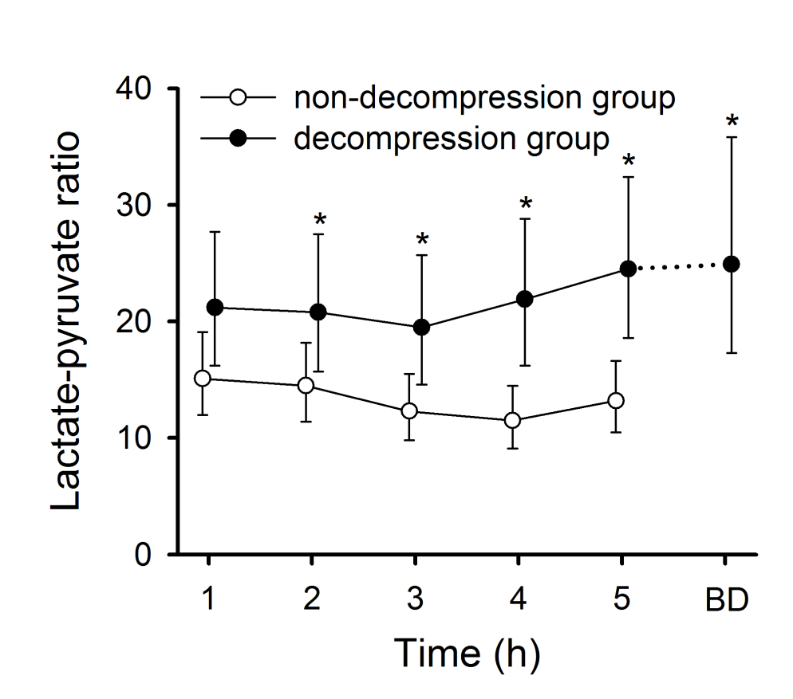

Conclusions: Ip l/p ratio and glycerol levels are elevated immediately postoperatively in patients developing IAH leading to organ failure and subsequent abdominal decompression.

